





* **Create a New Android Project**

Select **Empty Activity** template.

Name the project **DCP**.

* **Design the UI (activity_main.xml)**

Add two EditText fields for Name and Age.

Add two Button elements for **ADD** and **SHOW**.

Add a TextView to display the data.

* **Update the Manifest File (AndroidManifest.xml)**

Add the required permissions.

Ensure the MainActivity is declared with the **intent-filter** for the launcher.

* **Code the Logic (MainActivity.java)**

Initialize UI elements (EditText, Button, TextView).

Create or open an SQLite database using openOrCreateDatabase().

Create a table TABLE1 with name (text) and age (int).

Implement the **ADD** button logic to insert data.

Implement the **SHOW** button logic to retrieve and display data.

Handle potential exceptions to avoid app crashes.

* **Run the Application**





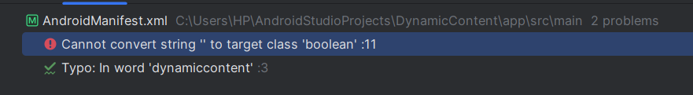



**Implementation Phase: Final Output(no error)**

**Step 1: Design the Layout**

* Open activity_main.xml from the **res → layout** folder.

• Drag a **Button** from the **Palette** to the design view.

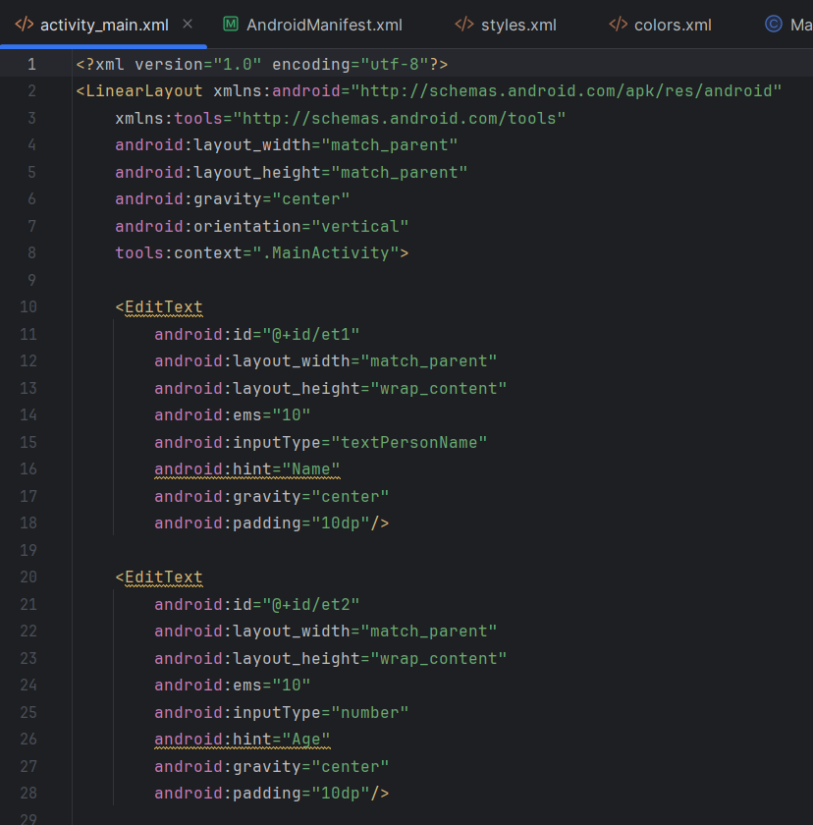

**Configuring styles.xml (For Custom Theme/Style)**

**Location:** res → values → styles.xml

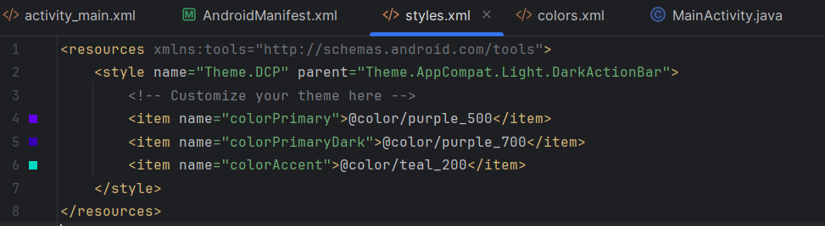



**Implementation Phase: Final Output(no error)**

Open AndroidManifest.xml in the app → src → main folder.

add android:exported="true" to the activity tag with an intent filter.

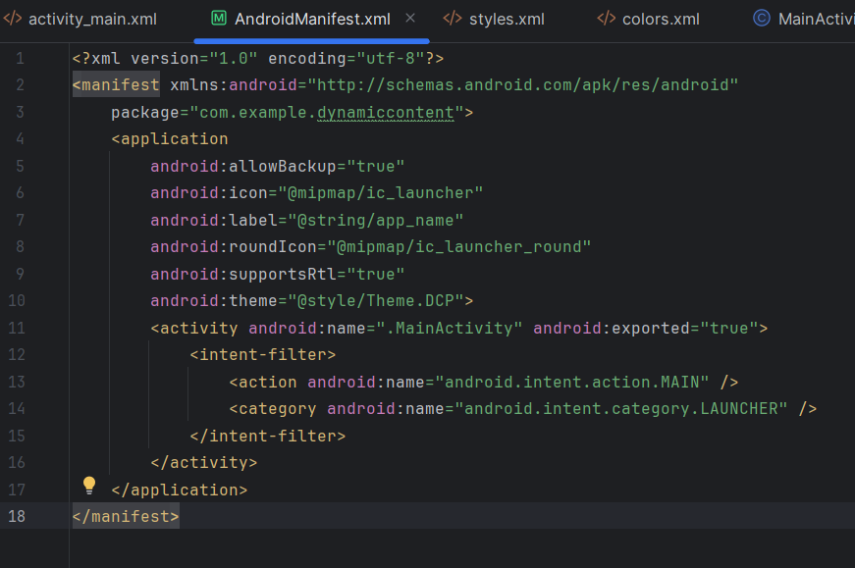

**Configuring Mainactivity.java**

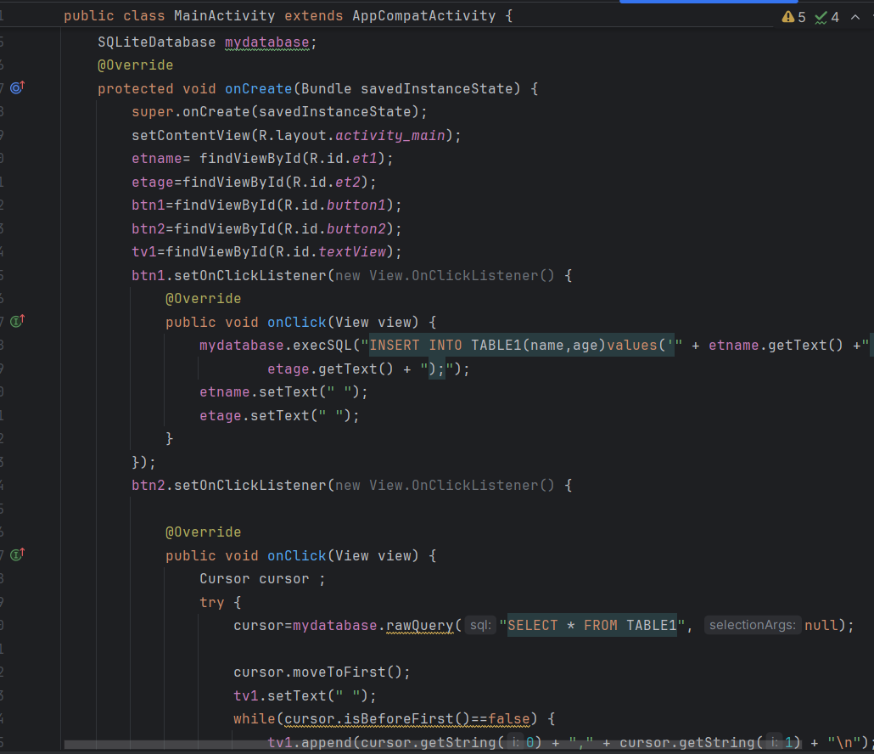



Click **Run** .





        
        
        
        
        
        
        
        
        



